**Lesson 11 Demo 2**

**Deploying Jenkins container on Docker**

**Objective:** Deploying Jenkins CI Tool on Docker host as Docker container.

**Tools required:** Linux and Docker.

**Pre-requisites:** You need to have VM up and running.

Steps to be followed:

1. Deploy Jenkins Docker image on Docker host

**Step 1: Deploy Jenkins Docker image on Docker host**

1. Login to VM with root user and make sure Docker service is up and running.
2. Next pull Jenkins Docker image on Docker using Docker pull command.

***docker image pull jenkins/jenkins:lts***

1. Once volume is created, proceed with container deployment using below set of commands:

***docker container run -d -p 8080:8080 \***

***--name jenkins-docker \***

***jenkins/jenkins:lts***

1. Once container is deployed access Jenkins using Docker host ip address and 8080 ports.

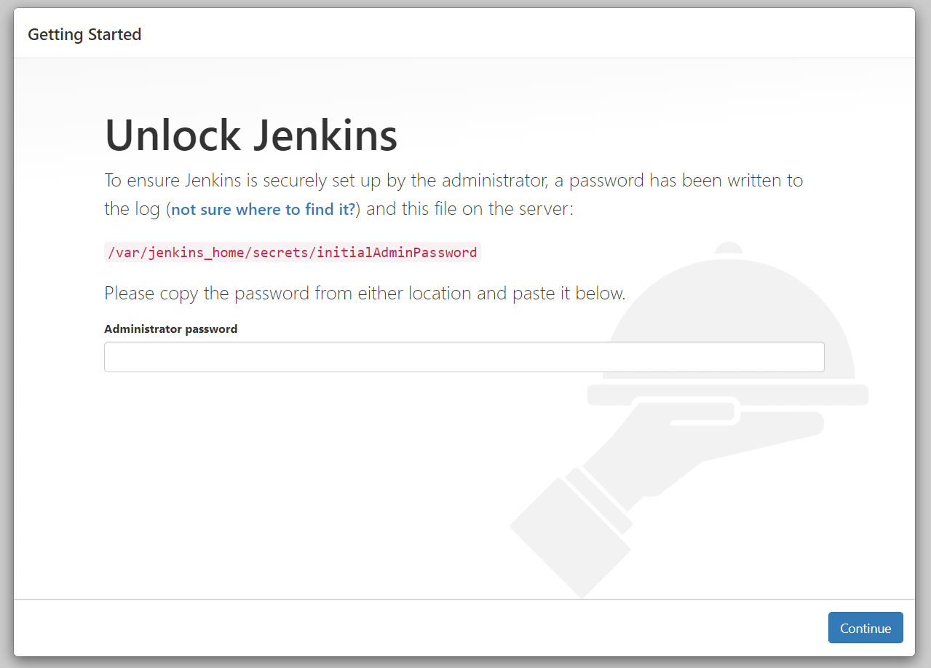

1. Next in order to proceed with configuration you need to get initialAdminPassword file content from docker container. Follow below command to fetch initial password.

***docker container exec [CONTAINER ID or NAME] \***

***sh -c "cat /var/jenkins_home/secrets/initialAdminPassword"***